Honeywell Xenon 1950
COM-Modus
05.06.2024
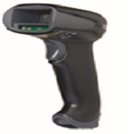
Reset the Custom Defaults: Activate Custom Defaults
Beeper Volume - Good Read: Low
Cellular Telephone Reading Mode: On
Plug and Play Codes: USB: USB Serial
Prefix: STX
Suffix: ETX
Presentation Aimer Mode: Interlaced


DEFALT;BEPLVL1;HSTACH18;HSTDCH20;DECCEL1;PREBK29902;SUFBK29903;PDCAIM2.

